**Sustainable Outreach And Universal**

**Leadership (SOUL) Limited**

**Software Requirement Specification (SRS)**

Of

**Project Plan Monitoring module**

For Implementation of

**Campus Management Software**

at

**World Skill Center (WSC)**

**Table of Content**

A. Abstract 3

B. Introduction 3

C. Definition, Acronyms and Abbreviations 3

D. Overview of the Document 3

E. Scope of Project Plan Monitoring Module 4

F. WSC Project Plan Monitoring Process Flow 4

G. Process Flow Description 4

H. List of Screen and their descriptions 4

I. Project Plan Monitoring 6

1. Project 6

2. Task 9

3. Project Template 11

4. Project Type 12

# Abstract

Software Requirements Gathering is one of the first phases of system development. This phase results in the Software Requirements Specification (SRS) document, which must contain a complete, concise, high-quality description of the system being considered.

# Introduction

The World Skill Center (WSC) is a premier advanced skill training institute established by the Government of Odisha, Skill Development and Technical Education Department, through the Odisha Skill Development Authority (OSDA). The WSC will impart advanced skill training in eight trades from engineering and service sectors. WSC caters primarily to induct the best talent from ITIs and Polytechnics and train them to become globally employable in emerging areas such as "Industry 4.0". WSC is housed in a state-of-the-art, 18-storey, air-conditioned building with nearly half a million square feet of space in the heart of capital city of Bhubaneswar.

With the Implementation of campus management software for WSC the goal is to streamline the operations and functions of the campus by integrating various processes, such as admissions, course registration, academic progress tracking, and financial management, HRMS, Procurement and Inventory management, etc into a unified system. The implementation also aims at providing a user-friendly interface for all stakeholders, making it easier for them to access the necessary information and complete their tasks with ease. The modules to be covered during the implementation of the software includes:

|  |  |
| --- | --- |
| Students Management Modules | Infrastructure Management |
| Academic System | Finance and Accounting System |
| Procurement & Inventory Management | Training and Placement |
| Human Resources Management System | Application Integration |

# Definition, Acronyms and Abbreviations

The following table explains the terms and abbreviations used in the document:

|  |  |
| --- | --- |
| **Abbreviation** | **Description** |
| SRS | Software Requirements Specification |
| SLCM | Student Life Cycle Management |
| NA | Not Applicable |

# Overview of the Document

This requirement document provides a detailed overview of the functional requirements of a project. It serves as a communication tool between stakeholders, including developers, project managers, and end-users. The purpose of this requirement document is to define and document the project's objectives, scope, and expectations, and to ensure that all stakeholders have a clear understanding of what the project entails.

This document covers all the functional requirements of the Project plan monitoring of ERP Product. This module helps in organizing the projects and tasks. This module covers the need of an organisation to track and update each of their processes to stay afloat and grow in the industry. The Project module helps an organization to keep track of such deliverables and ensure their timely completion.

# Scope of Project Plan Monitoring Module

* Database on ongoing Projects / Task
* Estimate preparation monitoring for new Project / Task
* Project Plan Monitoring

# WSC Project Plan Monitoring Process Flow

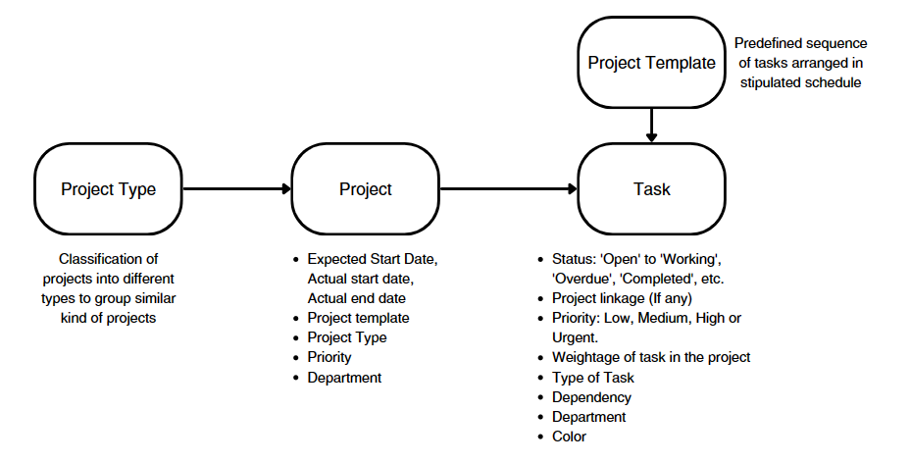

# Process Flow Description

1. First user will go to projects and create a new project and enter the project details, start and end date, project manager, project type, and status.
2. Then the user will go to task screen and create new task by entering task details like task name, description, start an end dates, task type, and status. Also, the user can assign to other users and set the task dependencies if required.
3. Now project template is a predefined sequence of tasks arranged in stipulated schedule. This created to make a template of tasks which can be used in different but similar process projects. The user is required to enter details like template name, default duration, default task list, and default project type.
4. Finally, Project type helps define and further help filter out projects. The project type only requires type name and description.

# List of Screen and their descriptions

The following tables lists the pages used in Academics module :

|  |  |  |
| --- | --- | --- |
| **Sl. No.** | **Screen Name** | Description |
| 1 | Project | Project management is task-driven. You can create a Project and divide it into multiple Tasks. |
| 2 | Task | In project management, a task is an actionable unit or activity which needs to be completed. Whilst each task within a Project can be assigned to an individual or a group of individuals, the assignment can also be done at the project level |
| 3 | Project Template | A Project Template is a predefined sequence of tasks arranged in stipulated schedule.  These templates can be pulled for similar kind of Projects and the tasks therein get auto-populated at the time of creation of each new project. |
| 4 | Project Type | A Project Type is the classification of projects into different types to group similar kind of projects. |

# Project Plan Monitoring

It will include details of hostels, new buildings, Primavera (tool currently being used), time taken to implement the project, delays and status of project, costing of the project, etc.

The Project module helps an organization to keep track of ongoing project deliverables and ensure their timely completion.

This module helps you manage your Projects by breaking them into Tasks and allocating them to different people.

Projects can be used to manage internal projects or service jobs. For service jobs, Time Sheets can also be created for billing purposes.

Purchasing can also be tracked against Projects and this can help the organisation keep tabs on its budget, delivery and profitability for a Project.

## **Project**

**General Description**

|  |  |
| --- | --- |
| **Description** | A Project is a planned piece of work that is designed to find information about something, to produce something new, or to improve something.  In this module, project management is task-driven. You can create a Project and divide it into multiple Tasks.  A Project has a broad scope and hence can be divided into tasks. Think of coming up with a new smartphone for the next year as a Project. Then things like designing, prototyping, testing, delivery, etc. become tasks under the project. |
| **Navigation** | **NA** |
| **Pre-requisites** | Project Type, Project template(if needed) |

**Screenshot**

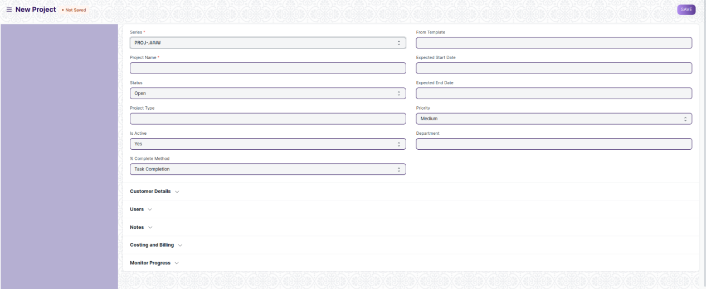

Figure 1: Project

**Field List**

The “Project” screen shall consist of the following fields:

|  |  |  |  |  |  |
| --- | --- | --- | --- | --- | --- |
| **ID** | **Field Label** | **Field Type** | **Validation/Action** | **Mandatory** | **Remarks** |
| 1 | Project Name | Text Field | User Input | Y |  |
| 2 | Status | Dropdown | Open  Completed  Cancelled |  |  |
| 3 | Project Type | Link | Fetched from Project type screen |  |  |
| 4 | Is Active | Dropdown | Yes  No |  |  |
| 5 | % Complete Method | Dropdown | Manual  Task Completion  Task Progress  Task Weight |  |  |
| 6 | % Completed | Percent |  |  |  |
| 7 | From Template | Link | Fetched from Project Template screen |  |  |
| 8 | Expected Start Date | Date picker | User Input |  |  |
| 9 | Expected End Date | Date picker | User Input |  |  |
| 10 | Priority | Dropdown | Medium  Low  High |  |  |
| 11 | Department | Link | Fetched from Department screen |  |  |
| 12 | Customer | Link | Fetched from Customer screen |  |  |
| 13 | Sales Order | Link | Fetched from Sales Order screen |  |  |
| 14 | **Project User** | Table | Project User Table is described below |  |  |
| 15 | Copied From |  |  |  |  |
| 16 | Notes | Text Editor | User Input |  |  |
| 17 | Actual Start Date (via Time Sheet) | Date picker | User Input |  |  |
| 18 | Actual Time (in Hours via Time Sheet) | Number | User Input |  |  |
| 19 | Actual End Date (via Time Sheet) | Date picker | User Input |  |  |
| 20 | Estimated Cost | Currency | User Input |  |  |
| 21 | Total Costing Amount (via Timesheets) | Currency | User Input |  |  |
| 22 | Total Purchase Cost (via Purchase Invoice) | Currency | User Input |  |  |
| 23 | Company | Link | Fetched from company screen |  |  |
| 24 | Total Sales Amount (via Sales Order) | Currency |  |  |  |
| 25 | Total Billable Amount (via Timesheets) | Currency |  |  |  |
| 26 | Total Billed Amount (via Sales Invoices) | Currency |  |  |  |
| 27 | Total Consumed Material Cost (via Stock Entry) | Currency |  |  |  |
| 28 | Default Cost Center | Link | Fetched from Cost Center screen |  |  |
| 29 | Gross Margin | Currency | User Input |  |  |
| 30 | Gross Margin % | Percent | User Input |  |  |
| 31 | Collect Progress | Check box | User Input |  |  |
| 32 | Holiday List | Link | Fetched from Holiday List screen |  |  |
| 33 | Frequency To Collect Progress | Dropdown | Hourly  Twice Daily  Daily  Weekly |  |  |
| 34 | From Time | Time picker | User Input |  |  |
| 35 | To Time | Time picker | User Input |  |  |
| 36 | First Email | Time picker | User Input |  |  |
| 37 | Second Email | Time picker | User Input |  |  |
| 38 | Daily Time to send | Time picker | User Input |  |  |
| 39 | Day to Send | Dropdown | Monday  Tuesday  Wednesday  Thursday  Friday  Saturday  Sunday |  |  |
| 40 | Weekly Time to send | Time picker | User Input |  |  |
| 41 | Message | Text Field | User Input |  |  |

|  |  |  |  |  |  |
| --- | --- | --- | --- | --- | --- |
| **Project User** | | | | | |
| **ID** | **Field Label** | **Field Type** | **Validation/Action** | **Mandatory** | **Remarks** |
| 1 | User | Link | Fetched from User screen |  |  |
| 2 | Email | Read Only | Auto fetched Based on User Field |  |  |
| 3 | Image | Read Only | Auto fetched Based on User Field |  |  |
| 4 | Full Name | Read Only | Auto fetched Based on User Field |  |  |
| 5 | Welcome email sent | Check Box | User Input |  |  |
| 6 | View attachments | Check Box | User Input |  |  |
| 7 | Project Status | Text Field |  |  |  |

**User: Roles & Permission**

The following table describes the users and their roles and permissions for the screens:

|  |  |  |  |  |  |  |  |  |  |
| --- | --- | --- | --- | --- | --- | --- | --- | --- | --- |
| **ID** | **Role** | **Select** | **Read** | **Write** | **Create** | **Delete** | **Submit** | **Cancel** | **Amend** |
| 1 | Project Manager | Yes | Yes | Yes | Yes | Yes | NA | NA | NA |
| 2 | Employee | No | Yes | No | No | No | NA | NA | NA |

## **Task**

**General Description**

|  |  |
| --- | --- |
| **Description** | In project management, a task is an actionable unit or activity which needs to be completed. Whilst each task within a Project can be assigned to an individual or a group of individuals, the assignment can also be done at the project level.  These Tasks can be created from a Project itself or a Task can be created separately as well. |
| **Navigation** | NA |
| **Pre-requisites** | NA |

**Screenshot**

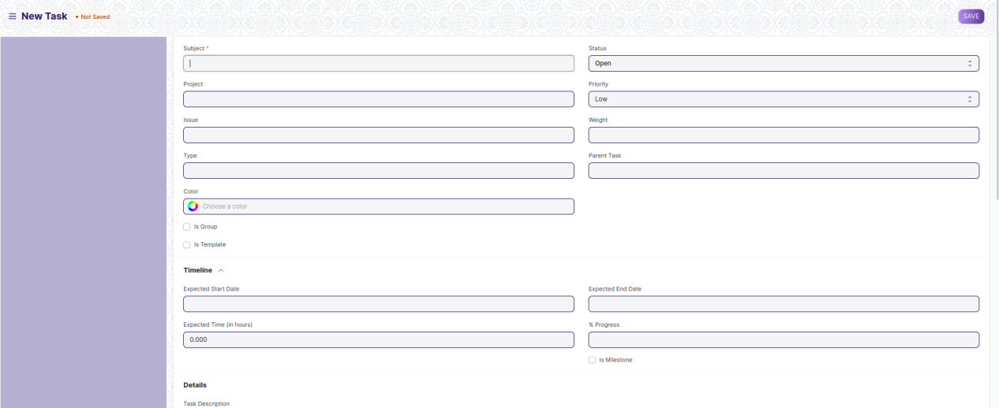

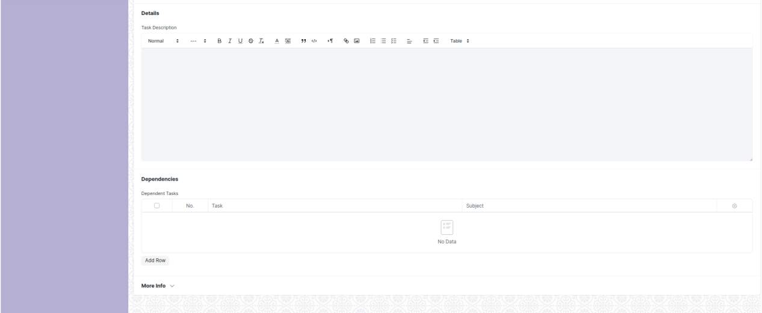

Figure 2: Task

**Field List**

The “Task” screen shall consist of the following fields:

|  |  |  |  |  |  |
| --- | --- | --- | --- | --- | --- |
| **ID** | **Field Label** | **Field Type** | **Validation/Action** | **Mandatory** | **Remarks** |
| 1 | Subject | Text Field | User Input | Y |  |
| 2 | Project | Link | Fetched from Project screen |  |  |
| 3 | Issue | Link | Fetched from Issue screen |  |  |
| 4 | Type | Link | Fetched from Task Type screen |  |  |
| 5 | Color | Color picker | User Input |  |  |
| 6 | Is Group | Check Box | User Input |  |  |
| 7 | Is Template | Check Box | User Input |  |  |
| 8 | Status | Drop down | Open  Working  Pending Review  Overdue  Template  Completed  Cancelled |  |  |
| 9 | Priority | Drop down | Low  Medium  High  Urgent |  |  |
| 10 | Weight | Number | User Input |  |  |
| 11 | Parent Task | Link | Fetched from Task screen |  |  |
| 12 | Completed By | Link | Fetched from User screen |  |  |
| 13 | Completed On | Date picker | User Input |  |  |
| 14 | Expected Start Date | Date picker | User Input |  |  |
| 15 | Expected Time (in hours) | Number | User Input |  |  |
| 16 | Begin On (Days) | Number | User Input |  |  |
| 17 | Expected End Date | Date picker | User Input |  |  |
| 18 | % Progress | Percent | User Input |  |  |
| 19 | Duration (Days) | Number | User Input |  |  |
| 20 | Is Milestone | Check Box | User Input |  |  |
| 21 | Task Description | Text Editor | User Input |  |  |
| 22 | **Task Depends On** | Table | Task Depends On Table is described below |  |  |
| 23 | Actual Start Date (via Time Sheet) | Date picker | User Input |  |  |
| 24 | Actual Time (in Hours via Time Sheet) | Number | User Input |  |  |
| 25 | Actual End Date (via Time Sheet) | Date picker | User Input |  |  |
| 26 | Total Costing Amount (via Time Sheet) | Currency | User Input |  |  |
| 27 | Total Billing Amount (via Time Sheet) | Currency | User Input |  |  |
| 28 | Review Date | Date picker | User Input |  |  |
| 29 | Closing Date | Date picker | User Input |  |  |
| 30 | Department | Link | Fetched from Department screen |  |  |
| 31 | Company | Link | Fetched from Company screen |  |  |

|  |  |  |  |  |  |
| --- | --- | --- | --- | --- | --- |
| **Task Depends On** | | | | | |
| **ID** | **Field Label** | **Field Type** | **Validation/Action** | **Mandatory** | **Remarks** |
| 1 | Task | Link | Fetched from Task screen |  |  |
| 2 | Subject | Text Field | User Input |  |  |
| 3 | Project | Text Field | User Input |  |  |

**User: Roles & Permission**

The following table describes the users and their roles and permissions for the screens:

|  |  |  |  |  |  |  |  |  |  |
| --- | --- | --- | --- | --- | --- | --- | --- | --- | --- |
| **ID** | **Role** | **Select** | **Read** | **Write** | **Create** | **Delete** | **Submit** | **Cancel** | **Amend** |
| 1 | Project Manager | Yes | Yes | Yes | Yes | Yes | NA | NA | NA |
| 2 | Employee | No | Yes | No | No | No | NA | NA | NA |

## **Project Template**

**General Description**

|  |  |
| --- | --- |
| **Description** | A Project Template is a predefined sequence of tasks arranged in stipulated schedule.  These templates can be pulled for similar kind of Projects and the tasks therein get auto-populated at the time of creation of each new project. |
| **Navigation** | NA |
| **Pre-requisites** | Task |

**Screenshot**

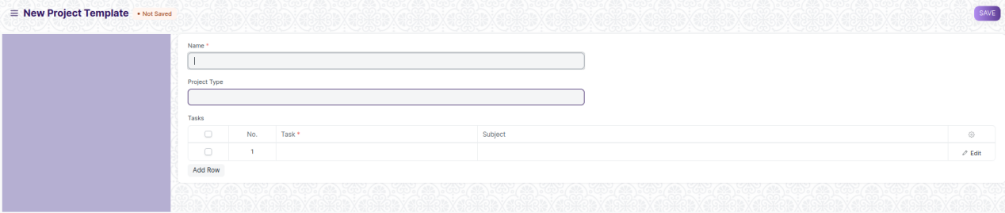

Figure 3: Project Template

**Field List**

The “Project Template” screen shall consist of the following fields:

|  |  |  |  |  |  |
| --- | --- | --- | --- | --- | --- |
| **ID** | **Field Label** | **Field Type** | **Validation/Action** | **Mandatory** | **Remarks** |
| 1 | Name | Text Field | User Input |  |  |
| 2 | Project Type | Link | Fetched from Project Type screen |  |  |
| 3 | **Project Template Task** | Table | User Input | Y |  |

|  |  |  |  |  |  |
| --- | --- | --- | --- | --- | --- |
| **Project Template Task** | | | | | |
| **ID** | **Field Label** | **Field Type** | **Validation/Action** | **Mandatory** | **Remarks** |
| 1 | Task | Link | Fetched from Task screen | Y |  |
| 2 | Subject |  | Read Only |  |  |

**User: Roles & Permission**

The following table describes the users and their roles and permissions for the screens:

|  |  |  |  |  |  |  |  |  |  |
| --- | --- | --- | --- | --- | --- | --- | --- | --- | --- |
| **ID** | **Role** | **Select** | **Read** | **Write** | **Create** | **Delete** | **Submit** | **Cancel** | **Amend** |
| 1 | Project Manager | Yes | Yes | Yes | Yes | Yes | NA | NA | NA |
| 2 | Employee | No | Yes | No | No | No | NA | NA | NA |

## **Project Type**

**General Description**

|  |  |
| --- | --- |
| **Description** | A Project Type is the classification of projects into different types to group similar kind of projects.  Internal Projects, External Projects could be examples of Project types and are already created in the system. You can choose to add more Project Types. This comes handy when you are reviewing the Projects, and you want to filter the information based on Project Types. |
| **Navigation** | NA |
| **Pre-requisites** | NA |

**Screenshot**

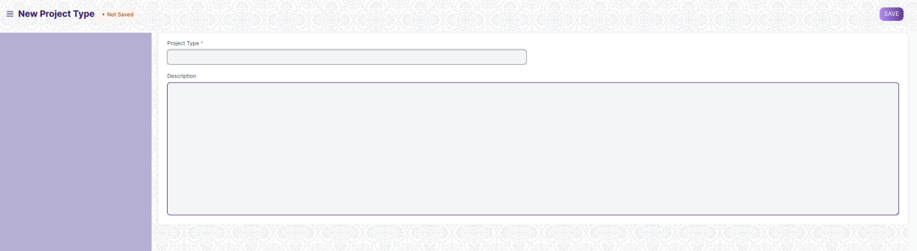

Figure 4: Project Type

**Field List**

The “Project Type” screen shall consist of the following fields:

|  |  |  |  |  |  |
| --- | --- | --- | --- | --- | --- |
| **ID** | **Field Label** | **Field Type** | **Validation/Action** | **Mandatory** | **Remarks** |
| 1 | Project Type | Text field | User Input | Y |  |
| 2 | Description | Text field | User Input |  |  |

**User: Roles & Permission**

The following table describes the users and their roles and permissions for the screens:

|  |  |  |  |  |  |  |  |  |  |
| --- | --- | --- | --- | --- | --- | --- | --- | --- | --- |
| **ID** | **Role** | **Select** | **Read** | **Write** | **Create** | **Delete** | **Submit** | **Cancel** | **Amend** |
| 1 | Project Manager | Yes | Yes | Yes | Yes | Yes | NA | NA | NA |
| 2 | Employee | No | Yes | No | No | No | NA | NA | NA |